Our Breakfast Program Benefits You and Your Children!

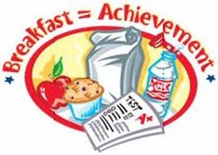
Did you know that?

The Cincinnatus Central School District offers a healthy and delicious meal for all students every morning?
Fact:
• Children who don’t eat breakfast are missing 25% of the nutrition they are supposed to be getting—and they don’t make that up during the rest of the day

Because:
• School Breakfast supplies 1/4 of the Recommended Daily Allowances your child needs

Convenient:
• It’s easy and convenient; there’s no need to worry if your children are eating nutritious breakfasts

• Eliminates arguing with children who just aren’t hungry when first waking up, which is quite common – students can eat before class time

• No more starting school on an empty stomach, feeling tired, hungry or irritable.

AND Breakfast Receives High Grades* 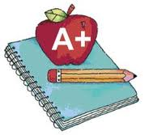
• Improves classroom performance and yields better test scores and grades
• Increases children’s ability to focus and concentrate on school work
• Decreases behavior problems, tardiness and visits to the nurse
• Increases attendance rates

Cost Friendly
School Breakfast is available to all students for free
So, Why are?
Less than half the students who qualify for free or reduced prices breakfast through the federal School Breakfast Program are eating it?

Remember to:
Encourage Your Child to Eat Breakfast at School!

*Based on the Maryland Meals for Achievement Year III Final Report 10/01 and the Minnesota Dept. of Children, Families & Learning Studies.
For the studies go to www.NutritionExplorations.org and click on the Parents Section.

